Name _________________________________________________________________________________________
 | 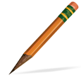  Write it with a pencil. | Write it with a marker. | Write with a colored pencil. | Write with a highlighter.
to
see
at
we
can
the
look
me

